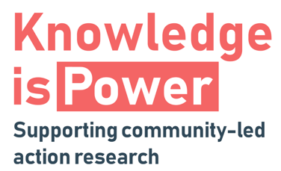
Knowledge is Power – selection criteria
The Knowledge is Power programme will support up to 6 organisations to conduct a local inquiry into an issue on which they wish to take action to effect change. In order to ensure that the support is directed to groups which are best suited to participate in the programme, and which will benefit from the support provided, we have developed the following criteria for assessing applications.
The support team will review applications based on these criteria and so we ask that this is taken into consideration when submitting your application.
Criteria:
- Groups must represent a clearly identifiable community. This might be a community of place (e.g. a neighbourhood, village) or a community of identity (people who share similar experiences such as disabled people, minority communities, fathers), or a community of interest (people who have a common social, cultural, environmental or recreational interest).
- Groups must be able to demonstrate that they are community-led. By this we mean organisations which are managed by and accountable to community members, which take action on issues identified by the community, and which work to benefit the whole community.
- Support will be prioritised for groups representing communities which experience disadvantage. Applicants should be able to describe how their community experiences disadvantage. This might include:
- groups with protected characteristics;
- groups experiencing economic disadvantage; and
- other indicators of deprivation such as rural isolation, age etc.
- Groups should be able to demonstrate that they have adequate capacity to participate fully in the programme. By this we mean that they can commit to participate in approximately 6 training sessions and workshops throughout the period of the programme; that they can carry out tasks between these sessions to progress the action research (e.g. briefing your local volunteers; meeting stakeholders); and that they can identify a core group of people who will be the project team. It is important to note that there will be a requirement for participating groups to carry out research tasks (e.g. carrying out interviews, surveys, collecting photographs, carrying out desk research). SCDC and the Poverty Alliance will provide support and training but the practical delivery will be the responsibility of community organisations. This ensures that the community group builds their skills and capability in the longer term. Our support time is limited, therefore we will prioritise where a group can demonstrate readiness to participate.
- Participating groups should have access to dedicated support, either within their organisation (e.g. development officer) or from elsewhere (e.g. from your local authority’s Community Learning and Development team). This support person will provide a key role in helping the group deliver their community-led action research project.
- The action research process will begin in Autumn 2019 so groups should be able to start their project at this time. A minimum of 3 people who will carry out the action research should be available to attend the training on Thursday 14th November 2019.
- The research must aim to improve outcomes and positively benefit the whole community by achieving change around the identified issue.

For more information or for any questions, please email hello@knowledgeisepower.scot
More information can also be found at https://www.knowledgeispower.scot/apply

The Equality Act 2010 protects people from discrimination because of a protected characteristic, which are as follows: age, disability, gender reassignment, marriage and civil partnership, pregnancy and maternity, race, religion or belief, sex, sexual orientation

